SDP Compliance Materialized Pipeline
Contributors | anikaushik
Reviewers
Security &
Compliance link/s
  - Change History
Date | Changes done | Author | Reviewers/Approvers
02-03-2026 | Document Inception | anikaushik
11-03-2026 | Added modified architecture diagram based on stageDataQuery being rendered redundant | anikaushik

  - Table of Contents
Introduction 2
Problem Statement 3
Optimization Attempts 4
Goals 4
Design Requirements 4
Current Design 5
Why the Monolithic Query Cannot Be Incrementally Processed 5
In Scope 5
Out of Scope 5
Design Proposal 6
Why Decompose into 3 Tables 6
The 3-Table Architecture 6
Table 1: all-stage-runs (Scoping) 6
Table 2: yaml-to-run-list (Bridge + Pipeline Name) 6
Table 3: stage-telemetry-policy-compliance (Runtime Enrichment + ServiceTree) 7
Assembly Order 8
Incremental Processing Design 9
Day-N Processing Flow 9
ADF Pipeline Design 10
Daily Pipeline Flow 10
Key Risk Mitigations 10
Late-Arriving Data 10
Deduplication 10
Backfill 10
Service Classification Instability 10
Cross-Midnight Runs (RunDate) 10
Risks and Dependencies 11
Future Add-ons 11
Alternatives Considered 11
Open Questions 11
References 11

Introduction

The SDP (Safe Deployment Practices) Compliance dashboard tracks deployment policy compliance for M365 services. It monitors whether pipeline stages follow required bake times, ring progression sequences, and minimum stage counts across ~6,200 pipeline definitions and ~210,000 runs and ~570,000 stages over a rolling 60-day window.
The dashboard is powered by KQL queries that join data from multiple Azure Data Explorer (ADX) clusters at refresh time. This document proposes a new architecture that pre-materializes the joined data into a flat ADX table via a daily ADF pipeline, replacing the current query-time join approach. This table will also prevent redundancy in having multiple different queries displaying the same data and will serve as the single source of truth for SDP onboarding and compliance information.

Problem Statement
The current dashboard query:
- Joins data across 4 ADX clusters: servicetreepublic.westus, onebranchm365release.eastus, 1es, and s360prodro
- Performs 10+ left-outer joins with mv-expand, parse_json, and cross-cluster calls
- Uses set notruncation and set norequesttimeout as workarounds
- Only retrieves the latest run per pipeline (via arg_max) due to scale constraints
Phase 2 requires all historical runs (~210K runs, ~570,000 stage-runs over 60 days), which exceeds ADX limits:

Limit | Threshold | Impact
Join memory budget | 5 GB default, 30 GB max | Error 80DA0001 — exceeded by 10+ joins on ~570K rows
Cross-cluster subquery truncation | 64 MB per subquery | May apply to remote calls; mitigated by local snapshots
Interactive query timeout | 4 min default, 1 hr max for client side | ~252s ceiling after all optimizations due to server side limits

Query Optimization Attempts
8 progressive optimizations were applied to the all-runs query. Each built on the previous, and all resulted in the same ~252-second timeout:
# | Optimization | Result
1 | Rewrote query for all runs (stage x run expansion) | Timeout ~252s
2 | Added set servertimeout = 1h | Timeout ~252s
3 | Replaced all cross-cluster calls to 1es with local snapshots (10 calls eliminated) | Timeout
4 | Replaced cross-cluster calls to servicetreepublic with local snapshots (2 calls eliminated) | Timeout
5 | Replaced explicit same-cluster references with local table names | Timeout
6 | Added materialize() to cache intermediate result | Timeout
7 | Added hint.strategy=shuffle on 3 heaviest joins | Timeout
8 | Filtered pipeline info to only MOBR pipelines before joins | Timeout

Conclusion: The query’s complexity (10+ left-outer joins on ~570K stage-run rows) fundamentally exceeds ADX’s interactive query execution limits. A different architecture is required.

Goals
- Materialize all historical stage-run data into a single pre-joined flat ADX table
- Support daily incremental processing (1-day slices appended to the table)
- Use local snapshot tables to avoid cross-cluster overhead and reduce query complexity
- Serve the PowerBI dashboard with simple read queries against the materialized table

Design Requirements
Requirement | Constraint
Data volume | ~570K stage-run rows over 60 days
Incremental support | Daily append of new data without reprocessing full window
Late-arriving data | Must handle telemetry arriving up to 24-48 hours late
Idempotency | Reruns and retries must not create duplicate rows
Memory limits | Each sub-query must stay within ADX per-operator memory budget
Timeout limits | Each execution must complete within ADX management command timeout
Correctness | Join results must be identical to running the full query on X days of data

Current Design
The current query (Current state of SDP dashboard query.md) is a single monolithic KQL script that:
- Queries servicetreepublic.westus (cross-cluster) for ServiceTree hierarchy
- Queries onebranchm365release.eastus (local) for PipelineRecords, TimelineRecords
- Queries 1es (cross-cluster, 10+ calls) for BuildYaml and BuildYamlMap
- Queries s360prodro (cross-cluster) for SDP action items
- Performs 10+ left-outer joins to combine all dimensions
- Returns only the latest run per pipeline via arg_max(Id, *)

Why the Monolithic Query Cannot Be Incrementally Processed
- Joins are interdependent. Intermediate results feed into downstream joins — stage ring analysis feeds into pipeline onboarding, which feeds into service classification. The entire chain must execute in one pass.
- Service-level classification requires the full window. isCosmicService and Ev2ServiceType aggregate across ALL pipelines for a service. Processing day 1 alone might misclassify services that have pipelines running on other days.
- "Latest YAML" retroactive interpretation. The old query uses arg_max(BuildId, YamlId) to get the single latest YAML per pipeline, then applies it to all historical runs. A YAML change retroactively alters all rows. This global dependency prevents day-by-day processing.
- Stage properties derived from YAML at query time. Ring, namespace, cloud, and task flags were extracted from YAML definitions (not runtime data), creating a dependency on the full YAML history. Due to this, parameterized values could not be parsed and showed up as $(VariableName).

In Scope
- Decomposition of the monolithic query into modular sub-queries supporting incremental processing and join logic.
- Schema design for each sub-table with defined keys and join relationships
- ADF daily (or depending on the frequency we choose based on source table ingestion frequency) pipeline for incremental materialization
- Initial backfill strategy (chunked by week)
- Deduplication and late-data handling

Out of Scope
- s360prodro SDP action items / wave classification — can be added as a future enrichment join
- PowerBI report redesign
- Materialized view design (e.g., SDP_LatestRun) (Will be discussed later)
- Service-level classification tables — Will be addressed as a periodic recompute
- Moving from Logs to M365Gating normalized tables (Will be discussed later)
- Policy Version handling (Will be discussed later)
- Migrating to PolicyHub for compliance data and creating the table in policy hub instead of MOBR MSI/PPE
- Cost of this table

Design Proposal
We propose adding a new table to onebranchreleasetelemetry database as it contains the required snapshot tables. The corresponding ADF pipelines will be added to the onebranch repo, same as for the current QEI. [Specifics to be added]
The architecture diagram below shows the required data flow and enrichment layers in our Proposed design:

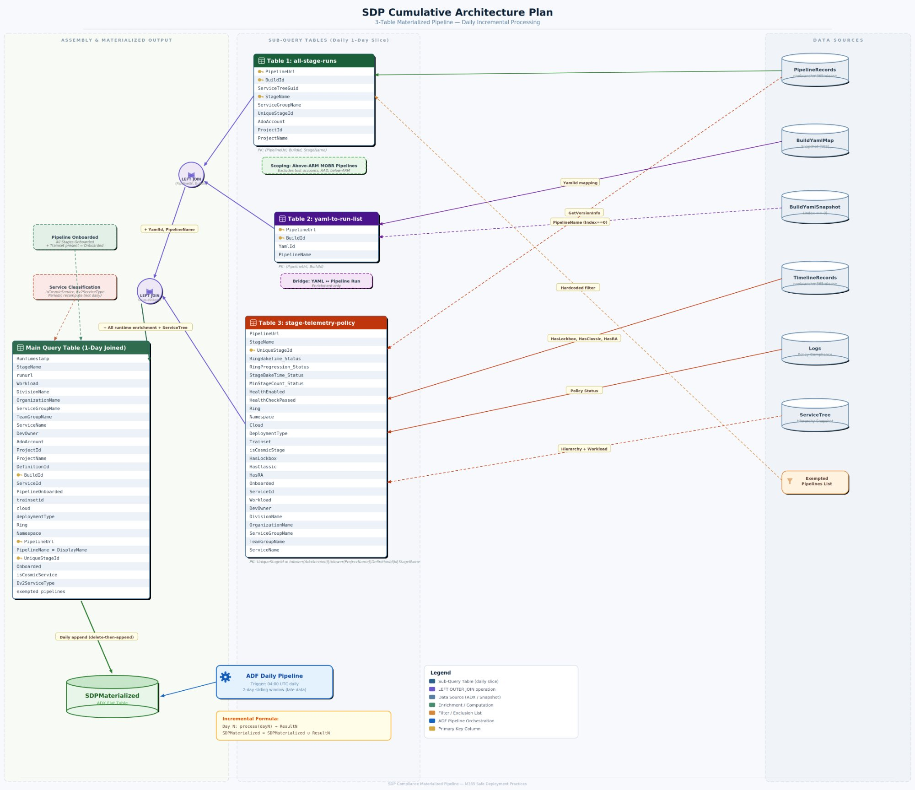
Figure 1: SDP Cumulative Architecture Plan

Why Decompose into 3 Tables
The key insight is that while the monolithic query cannot be partitioned by day, independent sub-queries can. By decomposing the monolith into sub-queries where each is self-contained per day, we enable incremental processing which allows us to build our table one day at a time without running into memory or timeout issues.
- Each sub-query reads from a single data source (PipelineRecords, BuildYamlMapSnapshot, or Logs/TimelineRecords)
- All join keys are scoped to a single run so a BuildId belongs to exactly one day
- No sub-query needs data from other days to produce correct output for its day
- Daily results can be joined and appended iteratively: Table = Table ∪ Result_N
Note: This was impossible with the old monolithic query because its joins create cross-day dependencies (e.g., service classification aggregates across all days).

The 3-Table Architecture

Table 1: all-stage-runs (Scoping)
Defines the universe of in-scope stages. Filters to above-ARM MOBR pipelines, excluding test accounts, AAD, and below-ARM pipelines. The exemptedPipelines filter must also be applied here (or as a post-join filter) to exclude known-exempt pipelines from compliance reporting.
Column | Type | Description
PipelineUrl | string | ADO pipeline URL
BuildId | long | Run/build identifier
ServiceTreeGuid | string | Effective ServiceId for this stage
StageName | string | Deployment stage name
ServiceGroupName | string | Service group from PipelineRecords
UniqueStageId | string | Composite key
AdoAccount | string | ADO account name
ProjectId | string | ADO project GUID
ProjectName | string | ADO project display name

Primary Key: (PipelineUrl, BuildId, StageName) / UniqueStageId

Table 2: yaml-to-run-list (Bridge + Pipeline Name)

Column | Type | Description
PipelineUrl | string | ADO pipeline definition URL
BuildId | long | Run/build identifier
YamlId | string | YAML definition identifier from BuildYamlMapSnapshot
PipelineName | string | Pipeline display name from BuildYamlSnapshot (Index == 0)

Primary Key: (PipelineUrl, BuildId)

Table 3: stage-telemetry-policy-compliance (Runtime Enrichment + ServiceTree)

Column | Type | Description
PipelineUrl | string | ADO pipeline URL
StageName | string | Stage Name derived from Environment based on version
UniqueStageId | string | Composite key
RingBakeTime_Status | int | Policy status (1=Pass, 2=Fail, 3=NotRun, 4=Missing)
RingProgression_Status | int | Policy status
StageBakeTime_Status | int | Policy status
MinStageCount_Status | int | Policy status
HealthEnabled | int | 1 if health-check-v1 exists
HealthCheckPassed | bool | true if all health checks passed
Ring | string | Deployment ring (from runtime MOBR/Cosmic logs)
Namespace | string | COSMIC namespace or “Non-Cosmic”
Cloud | string | Target cloud environment
DeploymentType | string | Normal / Emergency / GlobalOutage
Trainset | string | Trainset ID
isCosmicStage | int | 1 if COSMIC ring data exists
HasLockbox | int | 1 if Lockbox task present (TimelineRecords runtime)
HasClassic | int | 1 if ExpressV2Internal task present
HasRA | int | 1 if Ev2RARollout task present
Onboarded | int | 1 if Ring is non-empty AND in workload’s AllowedRings
ServiceId | string | ServiceTree GUID
Workload | string | Computed workload grouping
DevOwner | string | Dev owner from ServiceTree
OrganizationName | string | Organization name from ServiceTreeHierarchy
ServiceGroupName | string | Service group from ServiceTreeHierarchy
TeamGroupName | string | Team group from ServiceTreeHierarchy
ServiceName | string | Service Name from ServiceTreeHierarchy

Primary Key: UniqueStageId = AdoAccount|ProjectName|DefinitionId|RunId|StageName
Notes:
- HasLockbox, HasClassic, and HasRA are sourced from TimelineRecords (runtime), not YAML definitions. Runtime detection reflects what actually executed.
- Onboarded is computed using ServiceTree enrichment (ServiceId → Workload) and a ringworkload datatable (Workload → AllowedRings). Both are resolved within this query.

Assembly Order
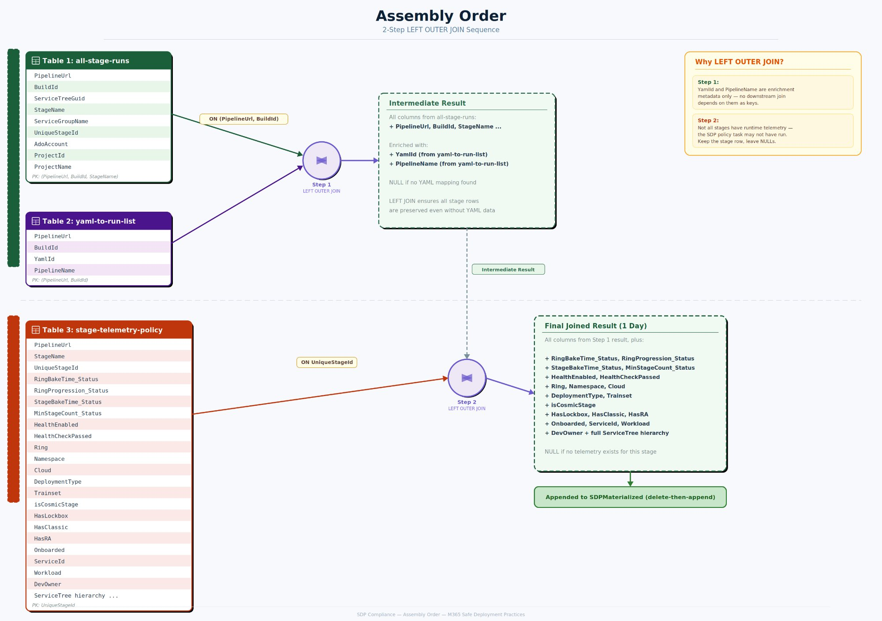
Figure 2: Assembly Order — 2-Step LEFT OUTER JOIN Sequence

Step 1 is left outer because YamlId and PipelineName are purely enrichment metadata — no downstream table uses them as join keys. Step 2 is left outer because if not all stages have runtime telemetry — the SDP policy task may not have run, or log entries may be missing. Keep the stage row, leave enrichment columns NULL. YamlIds are required to find the complete intended stage list in the latest run of the pipeline since these stages could be split across multiple runs.

Day-N Processing Flow
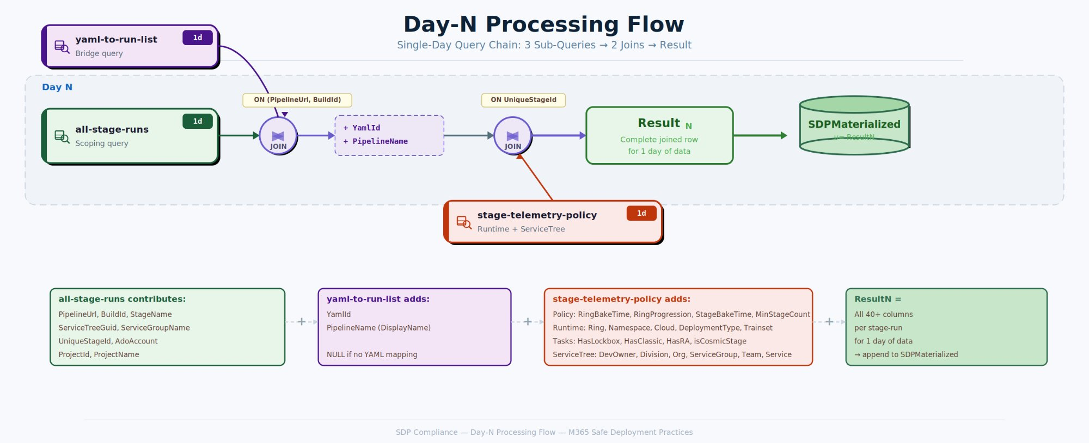
Figure 4: Day-N Processing Flow — Single-Day Query Chain

Incremental Processing Design
All 3 tables support daily incremental processing. Each day's slice is self-contained:
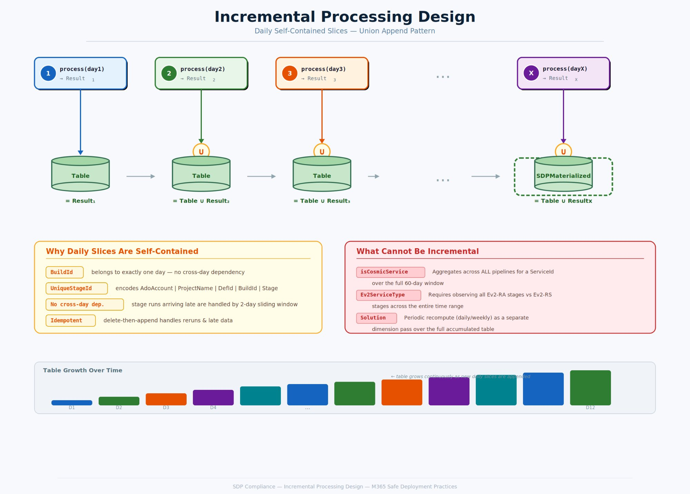
Figure 3: Incremental Processing Design — Daily Self-Contained Slices
Why this works:
- (PipelineUrl, BuildId) — a BuildId belongs to exactly one day
- UniqueStageId — encodes AdoAccount, ProjectName, DefinitionId, BuildId, StageName — fully identifies one stage in one run on one day
- No cross data dependency: stage run data which crossed over into another day compared to the pipeline start day can also be handled via sliding window approach.
What cannot be done incrementally:
- Service-level classification (isCosmicService, Ev2ServiceType) — aggregates across ALL pipelines for a ServiceId over the full window. Requires a periodic recompute pass over the full accumulated table.

ADF Pipeline Design

Daily Pipeline Flow
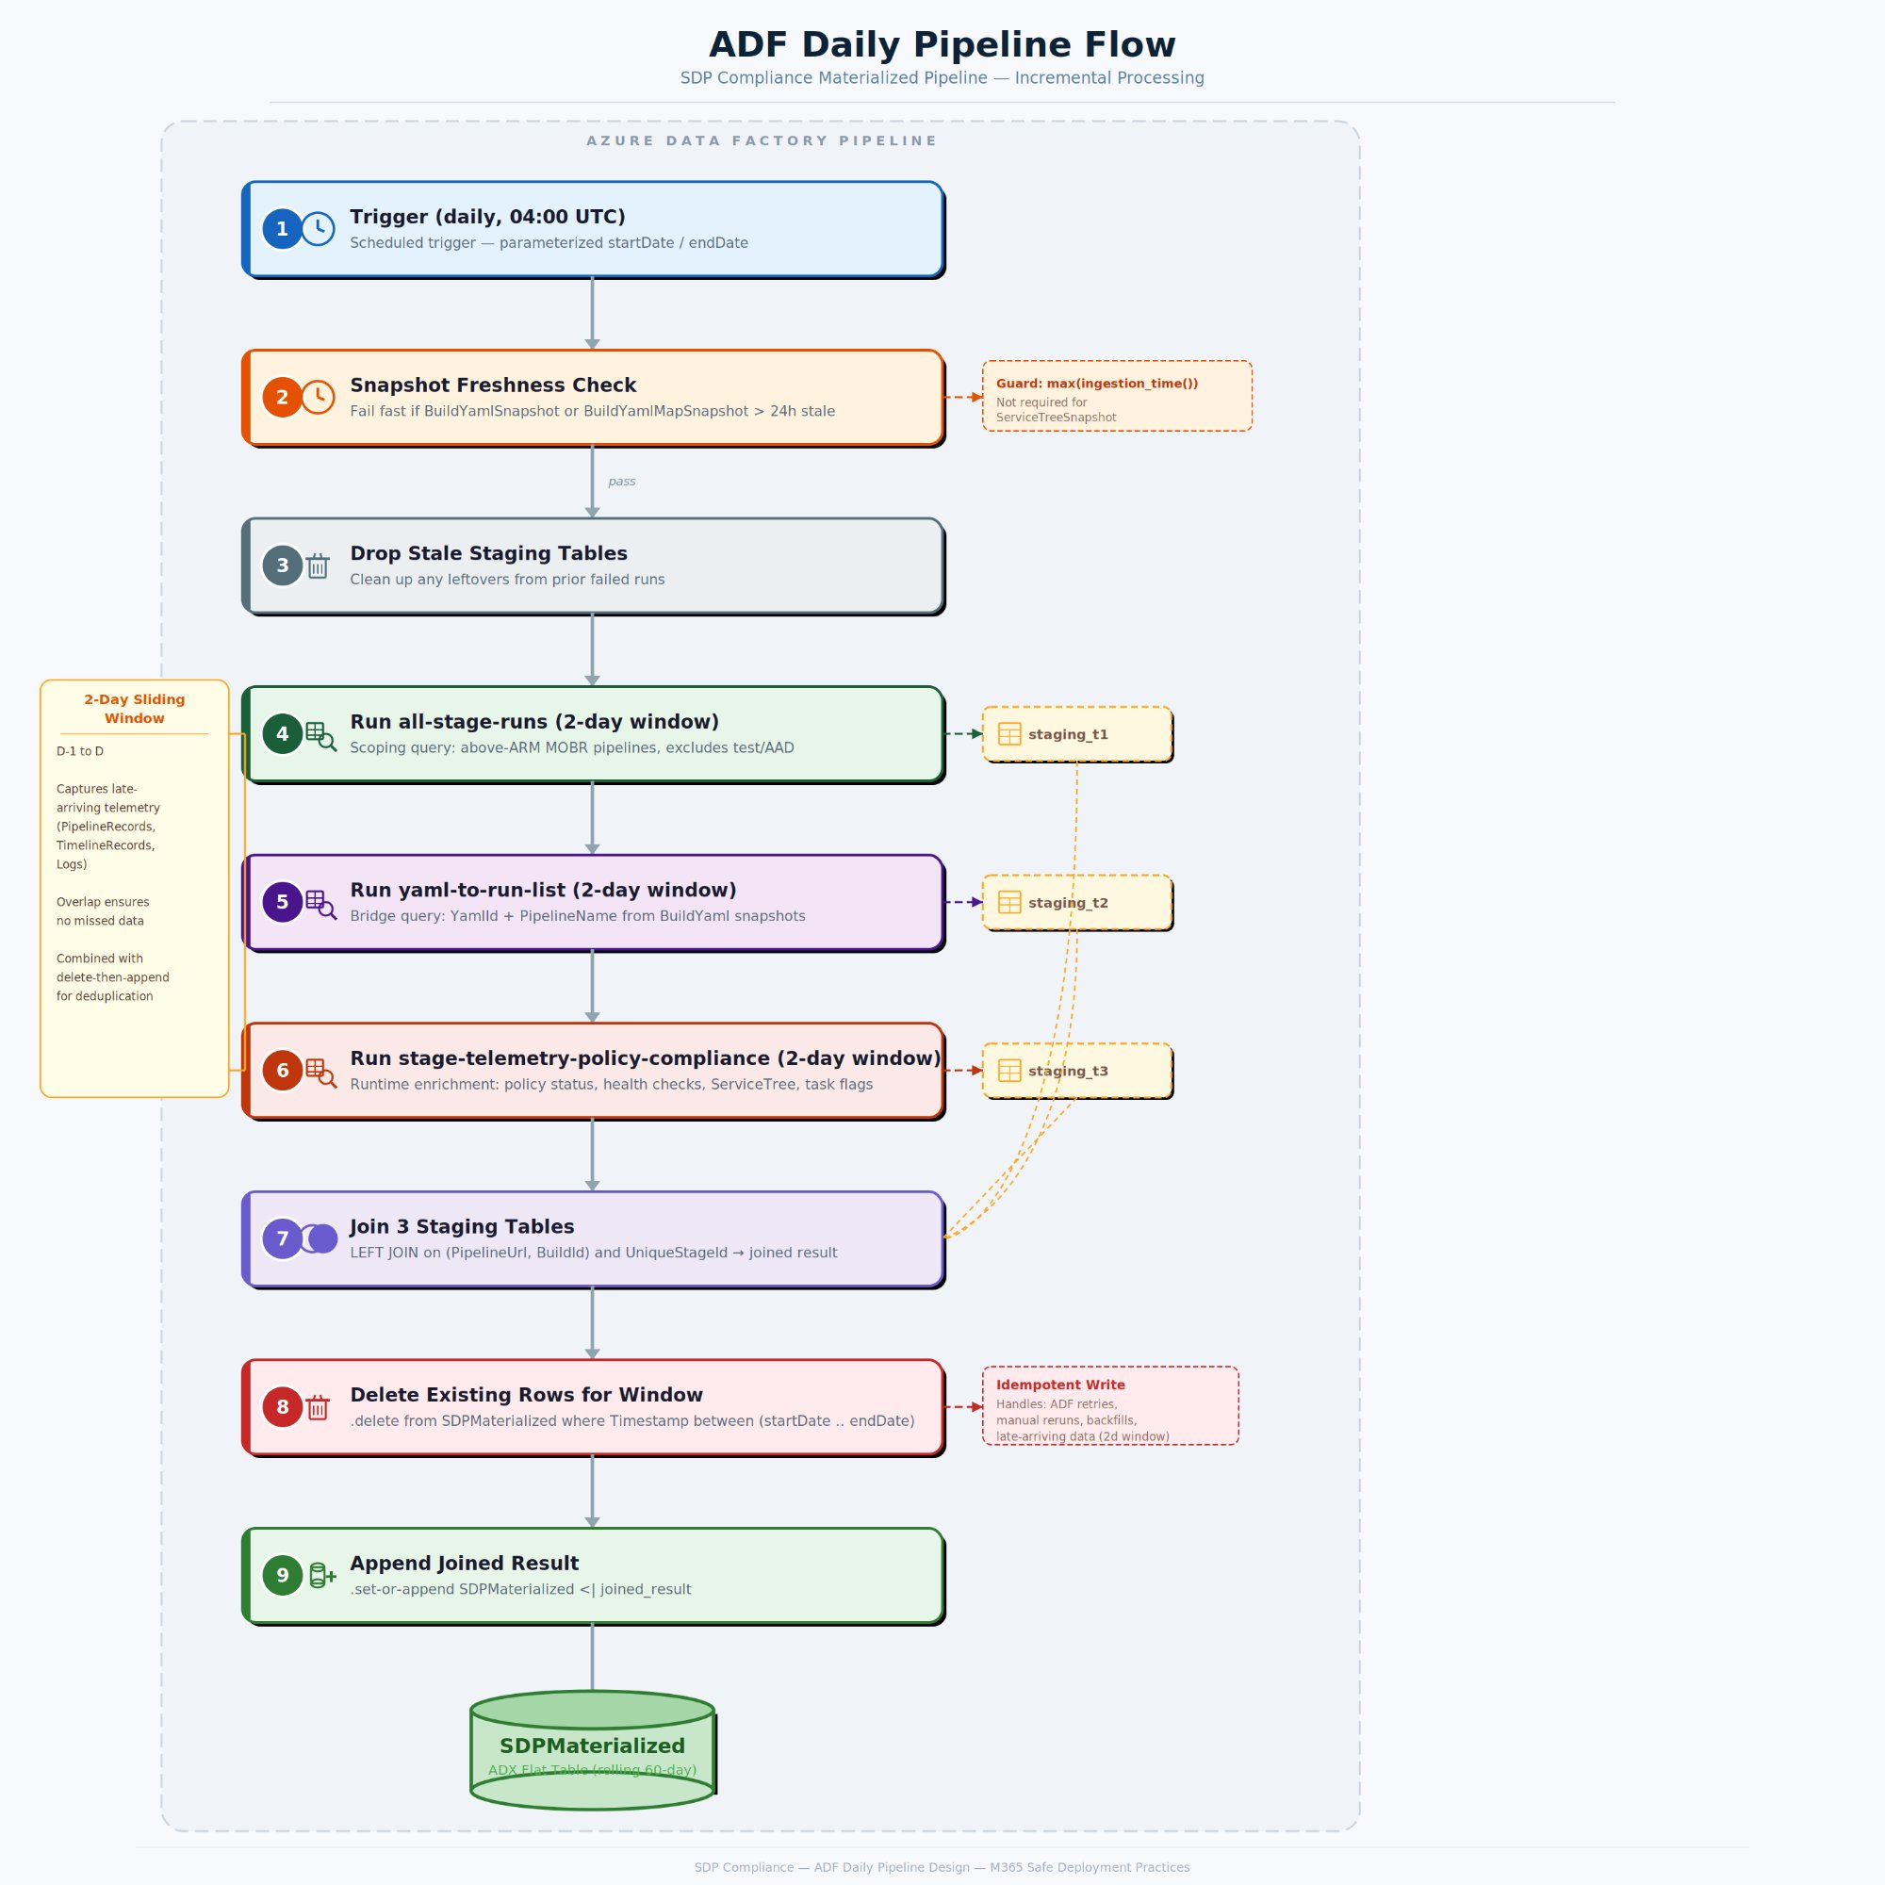
Figure 5: ADF Daily Pipeline Flow – Trigger time and window size may change based on requirements
Delete is based on uniqueStageId

Key Risk Mitigations

Late-Arriving Data
Telemetry tables (PipelineRecords, TimelineRecords, Logs) ingest asynchronously. A run on Day N may appear on Day N+1. Each daily execution processes a sliding 2-day window (D-1 to D), overlapping with the previous run. A 2-day window was chosen under the assumption that the vast majority of late-arriving data lands within 24 hours; the extra day of overlap keeps costs manageable while covering realistic ingestion delays. Combined with delete-then-append logic, this ensures late data is captured without duplication. However, this window will be adjusted if we notice significant telemetry arriving after 48 hours.

Deduplication
ADF retries, manual reruns, or backfills can execute the same day multiple times. The pipeline uses a delete-then-append strategy: first delete all existing rows for the reprocessing window (.delete from SDPMaterialized where Timestamp between (startDate .. endDate)), then append the fresh joined result via .set-or-append. This ensures idempotent writes and allows the sliding window to update existing rows with corrected data.

Backfill
Initial 60-day backfill is chunked into weekly windows (~220K stage-runs per chunk for 4 weeks) to stay within ADX memory limits. At ~750 bytes/row uncompressed, 220K rows ≈ 165 MB per chunk, well within the recommended 1 GB per .set-or-append operation. Each chunk will be a parameterized stored function call: SDP_BackfillChunk(startDate, endDate).

Service Classification Instability
isCosmicService and Ev2ServiceType depend on observing all stages and pipelines across the full-time range. These are computed as a separate periodic dimension recompute (daily or weekly), not as part of the daily fact load. This can be done over the full accumulated table since it's a global aggregation, not an incremental append.

Partial Write Failures
Results are written to a staging table first, then applied to the final fact table via delete-then-append (idempotent replace). ADX does not support multi-statement ACID transactions, so the delete and append are separate operations. If the pipeline fails mid-write, the staging table is dropped on retry — no partial state persists, and the next run's delete-then-append recovers automatically.

Cross-Midnight Runs (RunDate)
Pipeline runs that span midnight would appear in two daily windows if filtered naively by Timestamp. To prevent this, a canonical RunDate is assigned per BuildId based on the earliest PipelineRecords.Timestamp for that BuildId. All 3 sub-queries will filter on this RunDate rather than raw event timestamps, ensuring each run is processed exactly once in the window corresponding to its start. Some pipelines may run longer, to handle this, we can simply adjust stage data as it comes since we’ll get a timestamp associated with each stage run which will be included in the last one day period.

Rollback / Cleanup
At pipeline start, drop any staging tables left over from prior failed runs before writing new ones. This prevents stale intermediate data from contaminating the current execution.

Other Considerations
- Parameterized date ranges: ADF passes explicit startDate/endDate parameters. Queries never use now() to avoid clock skew.
- Snapshot freshness: The pipeline checks max(ingestion_time()) on snapshot tables (Not required for serviceTreeSnapshot) and fails fast if any snapshot is older than 24 hours.
- Consecutive failures: If the pipeline fails for 2+ consecutive days, a manual backfill is needed for the gap.

Risks and Dependencies
Risk | Mitigation
Snapshot tables stale (BuildYamlSnapshot, BuildYamlMapSnapshot) | Freshness check at pipeline start; fail fast if > 24h stale
2+ consecutive pipeline failures create data gaps | Manual backfill using SDP_BackfillChunk for affected date range
Type mismatch: BuildId (long) vs Id (string) [Handled, mentioned as a note for reference] | Join on UniqueStageId (string) avoids the mismatch

Future Add-ons
s360prodro SDP action items: Wave classification (e.g., "Wave 8") from cluster('s360prodro').database('service360db') can be added as an additional left-outer join enrichment on PipelineUrl. Small dataset, minimal cross-cluster overhead.

Alternatives Considered
Approach | Reason for Rejection
In-query optimization | 8 attempts, all timed out at ~252s. Join scale exceeds ADX interactive limits.
ADX Update Policies | Designed for per-record enrichment, not global reconciliation.
ADX Continuous Export | Targets external storage, cannot write to another ADX table.
Daily windowing on monolith | Joins are interdependent — cannot partition by day.
Full replace daily | Correct but expensive — recomputes entire 60-day window daily. Not feasible currently. Does not Scale.

Fast Follow-ups
- Exact ADF scheduling time and retry policy
- Retention period for the materialized table (e.g., rolling 90 days, or full history)
- Whether to implement a weekly full-rebuild consistency check
- Policy version column addition

References
Resource | Description
schema.md | 3-table schema reference with keys, joins, and incremental processing analysis
all-stage-runs.md | Scoping sub-query
yaml-to-run-list.md | YAML bridge sub-query
stage-telemetry-policy-compliance.md | Runtime enrichment sub-query
Current state of SDP dashboard query.md | Old monolithic cross-cluster query
ADF-Pipeline-Design.md | ADF data risks and required protections

